**WEEK 11**

**1# Create an inter University Database with the following relations. Include at least four attributes for each table. • University • Department • Program • Course • Syllabus • Faculty(Teacher)**

**a) Create above tables and mention primary keys and foreign keys. Also create secondary index for each table.**

**b) Insert at least 5 relevant records in each of the created tables.**

create database universities;

use universities;

CREATE TABLE University (

university_id INT PRIMARY KEY,

university_name VARCHAR(100),

location VARCHAR(100)

);

CREATE TABLE Department (

department_id INT PRIMARY KEY,

department_name VARCHAR(100),

university_id INT,

FOREIGN KEY (university_id) REFERENCES University(university_id)

);

CREATE TABLE Program (

program_id INT PRIMARY KEY,

program_name VARCHAR(100),

university_id INT,

FOREIGN KEY (university_id) REFERENCES University(university_id)

);

CREATE TABLE Course (

course_id INT PRIMARY KEY,

course_name VARCHAR(100),

program_id INT,

FOREIGN KEY (program_id) REFERENCES Program(program_id)

);

CREATE TABLE Syllabus (

syllabus_id INT PRIMARY KEY,

syllabus_name VARCHAR(100),

university_id INT,

FOREIGN KEY (university_id) REFERENCES University(university_id)

);

CREATE TABLE Faculty (

faculty_id INT PRIMARY KEY,

faculty_name VARCHAR(100),

specialization VARCHAR(100),

university_id INT,

FOREIGN KEY (university_id) REFERENCES University(university_id)

);

CREATE INDEX idx_university_location ON University(location);

CREATE INDEX idx_department_university_id ON Department(university_id);

CREATE INDEX idx_program_university_id ON Program(university_id);

CREATE INDEX idx_course_program_id ON Course(program_id);

CREATE INDEX idx_syllabus_university_id ON Syllabus(university_id);

CREATE INDEX idx_faculty_university_id ON Faculty(university_id);

INSERT INTO University (university_id, university_name, location) VALUES

(1, 'Delhi University', 'Delhi'),

(2, 'Jawaharlal Nehru University', 'Delhi'),

(3, 'Aligarh Muslim University', 'Aligarh'),

(4, 'University of Jammu', 'Jammu'),

(5, 'Jamia Millia Islamia', 'Delhi');

INSERT INTO Department (department_id, department_name, university_id) VALUES

(101, 'Computer Science', 1),

(102, 'Physics', 2),

(103, 'Mathematics', 1),

(104, 'Chemistry', 3),

(105, 'Management Studies', 4);

INSERT INTO Program (program_id, program_name, university_id) VALUES

(201, 'MCA', 1),

(202, 'MA in International Relations', 2),

(203, 'B.Tech in Mechanical Engineering', 4),

(204, 'M.Sc in Chemistry', 3),

(205, 'MBA', 5);

INSERT INTO Course (course_id, course_name, program_id) VALUES

(301, 'Database Management Systems', 201),

(302, 'Foreign Policy Analysis', 202),

(303, 'Thermodynamics', 203),

(304, 'Organic Chemistry', 204),

(305, 'Marketing Management', 205);

INSERT INTO Syllabus (syllabus_id, syllabus_name, university_id) VALUES

(401, 'Computer Architecture', 1),

(402, 'International Relations Theory', 2),

(403, 'Fluid Mechanics', 4),

(404, 'Analytical Chemistry', 3),

(405, 'Financial Management', 5);

INSERT INTO Faculty (faculty_id, faculty_name, specialization, university_id) VALUES

(501, 'political science', 'Computer Networks', 1),

(502, 'science', 'Political Science', 2),

(503, 'education', 'Thermal Engineering', 4),

(504, 'medicine', 'Organic Chemistry', 3),

(505, 'engineering', 'Marketing', 5);

**i) List of Universities situated at Delhi**

SELECT university_name

FROM University

WHERE location = 'Delhi';

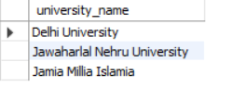

**ii) List of all Departments of AMU**

SELECT department_name

FROM Department

WHERE university_id = (SELECT university_id FROM University WHERE university_name = 'Aligarh Muslim University');

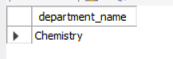

**iii) Find the location of JNU.**

SELECT location

FROM University

WHERE university_name = 'Jawaharlal Nehru University';

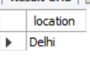

**iv) List of all Programs run by University of Jammu.**

SELECT program_name

FROM Program WHERE university_id = (SELECT university_id FROM University WHERE university_name = 'University of Jammu');

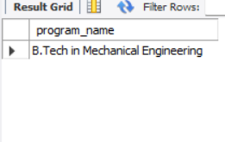

**v) List of Universities that run Program "MCA"**

SELECT u.university_name FROM University u

JOIN Program p ON u.university_id = p.university_id

WHERE p.program_name = 'MCA';

**vi) List of Courses of "MCA" run by AMU.**

SELECT c.course_name

FROM Course c

JOIN Program p ON c.program_id = p.program_id

JOIN University u ON p.university_id = u.university_id

WHERE u.university_name = 'Aligarh Muslim University' AND p.program_name = 'MCA';

**vii) List of Faculties specialized in "Information Security" across different universities.**

SELECT faculty_name, university_name

FROM Faculty f

JOIN University u ON f.university_id = u.university_id

WHERE specialization = 'Information Security';

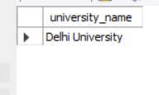

**viii) Syllabus of "Computer Architecture" of different Universities.**

SELECT syllabus_name, university_name

FROM Syllabus s

JOIN University u ON s.university_id = u.university_id

WHERE syllabus_name = 'Computer Architecture';

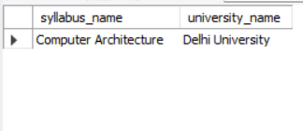

**ix) List of all faculties of Department of Computer Science of Delhi University.**

SELECT faculty_name

FROM Faculty f

JOIN Department d ON f.university_id = d.university_id

JOIN University u ON d.university_id = u.university_id

WHERE d.department_name = 'Computer Science' AND u.location = 'Delhi';

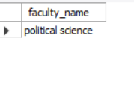

**x) Find the University which has maximum Departments.**

SELECT university_name

FROM University

WHERE university_id = (

SELECT university_id

FROM Department

GROUP BY university_id

ORDER BY COUNT(*) DESC

LIMIT 1

);

